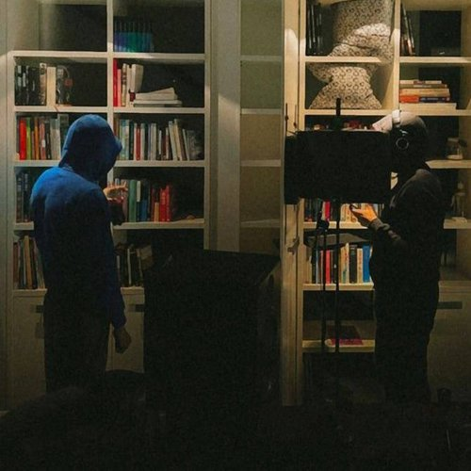 |  | Ochilov Shamshod  Male, 18 years, born on 10 October 2007  +998 (93) 8004510 — preferred means of communication  shamshodochilov165@gmail.com  Reside in: Tashkent  Citizenship: Uzbekistan, work permit at: Uzbekistan  Ready to relocate: Tver, ready for rare business trips
Desired position and salary
Frontend-разработчик  Specializations:  — Programmer, developer  Employment type: full time, part time, project work, work placement  Work format: remote, at the employer's location, hybrid, traveling, rotation  travel time to work: any |  |  | 600 $ in hand
Work experience —1 year 3 months
January 2025 — till now  1 year 3 months |  | Tashkent Airport Hotel  Frontend-разработчик  Responsible for developing and maintaining the client-side of web applications, creating responsive and user-friendly interfaces, and ensuring high performance and usability. Tasks include integrating APIs and services, refactoring and improving existing code, debugging and testing for cross-browser compatibility, and optimizing overall frontend architecture. Actively collaborate with designers and backend developers to deliver efficient, reliable, and modern web solutions.
Education
Level |  | Secondary school
Skills
Languages |  | Uzbek — Native
Skills |  | JavaScript HTML Git TypeScript React CSS3 Английский язык HTML5 UI Scss Render Vercel Sass React router Vite GitHub Bootstrap Node.js Веб-программирование Веб-аналитика

